ITP 359

Homework 1
25 points
Review of deep Neural Networks

Predict New York Taxi fares using Deep Neural Networks (20 points)
Predict the fare amount for a taxi ride in New York City given the pickup and dropoff locations. While you can get a basic estimate based on just the distance between the two points, this will result in an RMSE of $5-$8, depending on the model.
Download the data file of fares from Blackboard.
The file contains these columns.
- key - Unique string identifying each row. Comprised of pickup_datetime plus a unique integer, but this doesn't matter, it should just be used as a unique ID field.
- pickup_datetime - timestamp value indicating when the taxi ride started.
- pickup_longitude - float for longitude coordinate of where the taxi ride started.
- pickup_latitude - float for latitude coordinate of where the taxi ride started.
- dropoff_longitude - float for longitude coordinate of where the taxi ride ended.
- dropoff_latitude - float for latitude coordinate of where the taxi ride ended.
- passenger_count - integer indicating the number of passengers in the taxi ride.

Target
- fare_amount - float dollar amount of the cost of the taxi ride.

For this homework, use tensorflow and keras to build and train a deep neural network to predict taxi fares. Here are the requirements.
- Read the dataset into a dataframe. Parse the pickup_datetime so that it is read as timestamp. (1)
- Explore the dataset and determine what is the target variable. (1)
- Drop factor(s) that are not likely to be relevant for predicting the taxi fare. (2)
- You will notice that several rides have 0 for latitude and/or longitude data. You may wan to drop these rides for better model performance.
- Extract the weekday and the time (hours/minutes) from the pickup_datetime. Store in the data frame. Drop the pickup_datetime. (2)
- Compute the distance between pickup_longitude and dropoff_longitude by using this approximate formula for relatively close points in the earth (e.g. within NYC) (2)
a = diff in longitude of two points * 54.6
b = diff in latitude of two points * 69.0
distance in miles = sqrt (a^2 + b^2)

- Drop latitude and longitude columns. (1)
- Assign X (features variables) and y (target variable) (1)
- Build a keras sequential model with two dense layers. Number of neurons is your choice (> 50). Activation function is your choice. (3)
- Add a dense output layer. How many neurons in this layer? (2)
- Compile the model with optimizer as adam, loss as mean squared error, metrics as mean squared error. (2)
- Train the model. Partition with a split of 70/30. Epochs > 30. (2)
- Display the plot of the training and validation accuracy vs epoch. (2)
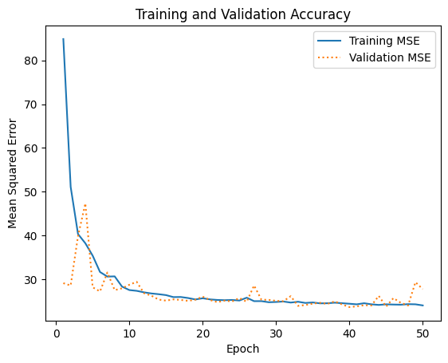
- Print the R-squared score. (1)
- Finally, print the prediction of taxi fare for 2 passengers riding 3.2 miles at 3:20 pm on a Friday. (3)
Submit the Python notebook on Brightspace.

https://www.kaggle.com/competitions/new-york-city-taxi-fare-prediction

